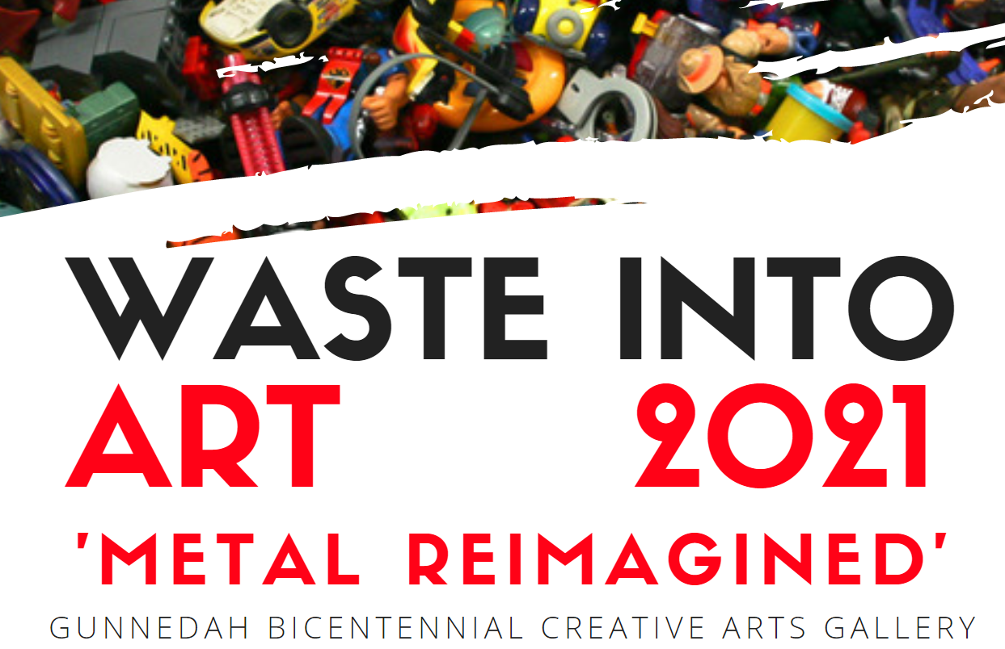

ARTIST AGREEMENT / TERMS & CONDITIONS:

1. Artworks to be submitted by 5:00 pm Monday 24 May, 2021 to The Gunnedah Bicentennial Creative Arts Gallery 81 Chandos Street, Gunnedah NSW 2380, Australia with ‘Artist Submission Form ‘completed and attached. All artworks MUST BE clearly labelled with the entrant’s name, medium, price & artwork name upon delivery with suitable hanging or installation mechanisms on all submitted artworks.
2. Entrants must reside in the New England North West Area.
3. The entry must be the original work of the artist. The item cannot have ever previously been entered in the Waste into Art Competition.
4. All artworks must incorporate the re-use or recycling of waste or pre/loved materials and/or may link to the theme ‘Metal Reimagined’
5. Council will not take responsibility for any loss or damage that may occur to entries. However, reasonable care will be applied in dealing with the entries submitted.
6. Competition coordinators reserve the right to amend the entry category specified by the entrant if it is deemed to be incorrect. Competition coordinators reserve the right to reject, as deemed by them, inappropriate artworks
7. Entrants in the School class sections will win prizes on behalf of their school.
8. Artworks will be displayed in The Gunnedah Bicentennial Creative Arts Gallery, Gunnedah from Friday 28 May, 2021 to Friday 2 July, 2021. The Official Opening will occur at 1:00pm Friday 28 May, 2021.
9. Artworks cannot be removed from the Gallery before the closing date of the exhibition. All artworks remain the property of the entrant or purchaser and must be collected immediately after the exhibition closes.
10. Gunnedah Shire Council will receive 25% commission of any sales of artwork within the gallery.
11. The artist agrees that their artwork may be photographed and used in any promotional materials now or in the future; at the discretion of Gunnedah Shire Council and approved media.

By completing, signing and submitting this “Waste into Art Submission Form”, the artist confirms that they have read these terms and conditions, and agree to participate in accordance with them. For more information contact: Gunnedah Shire Council on (02)67402 100 or via email council@infogunnedah.com.au

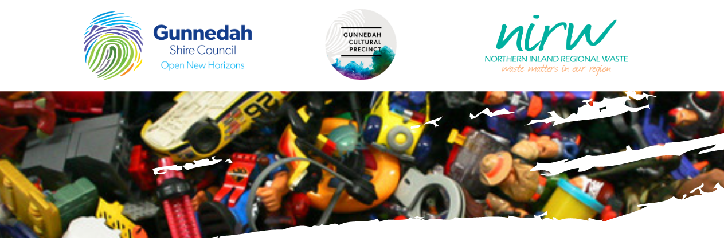

WASTE INTO ART 2021 SUBMISSION FORM

COMPETITION CATEGORIES:

SCHOOLS AND STUDENTS  - Early Childhood / Preschools  - Primary Schools  - Secondary Schools | OPEN COMMUNITY  - Most Creative  - Best suits theme of ‘Metal Reimagined’  - Functional Art (Furniture/Homewares/Inventions) | PEOPLE’S CHOICE AWARD  - The artwork voted the ‘best’ by patrons

JUDGING CRITERIA:
Winners will be selected from the various sections and will be judged on the following criteria:
- Demonstration of reuse or recycling of waste / pre-loved materials
- Craftsmanship and quality of artwork
- Aesthetic Merit, Creativity & Inspiration
- Relevance to selected category

WINNERS OF EACH CATEGORY WILL RECEIVE $150.00

ARTIST / COLLECTIVE’S NAME OR
CLASS, TEACHER AND SCHOOL NAME:
CONTACT NUMBER:
EMAIL:
DETAILS OF ARTWORK
TITTLE | MEDIUM | PRICE | CATEGORY
NB: THERE IS NO MAXIMUM AMOUNT OF ENTRIES PER ARTIST OR COLLECTIVE. IF YOU ENTER MORE THAN THREE WORKS SIMPLY OBTAIN ANOTHER ENTRY FORM
SIGNATURE: |  |  | DATE: / /2021

