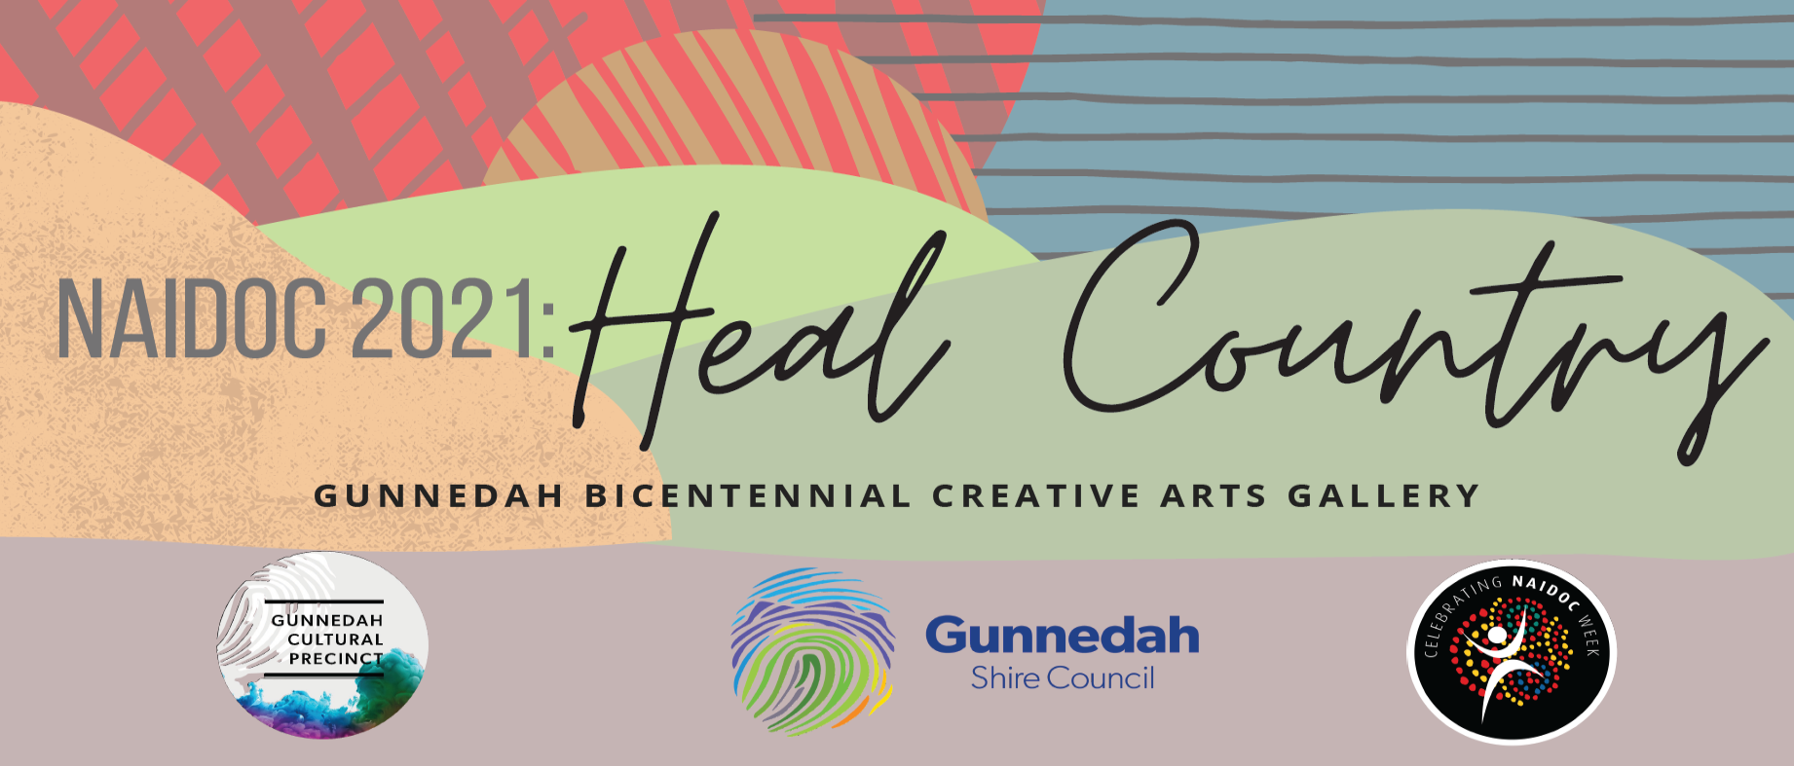

ARTIST AGREEMENT / TERMS & CONDITIONS:

- Submissions open 9.00AM MONDAY 28 JUNE, 2021 & CLOSE 5.00PM MONDAY 5 JULY, 2021 to The Gunnedah Bicentennial Creative Arts Gallery 81 Chandos Street, Gunnedah NSW 2380, Australia with ‘Artist Submission Form ‘completed and attached. All artworks MUST BE clearly labelled with the entrant’s name, medium, price & artwork name upon delivery with suitable hanging or installation mechanisms on all submitted artworks.
- The entry must be the original work of the artist
- Competition coordinators reserve the right to reject, as deemed by them, inappropriate artworks
- Artworks will be displayed in The Gunnedah Bicentennial Creative Arts Gallery, Gunnedah from Friday 9 July, 2021 to Friday 06 August, 2021. Artworks cannot be removed from the Gallery before the closing date of the exhibition. All artworks remain the property of the entrant or purchaser and must be collected immediately after the exhibition closes.
- Gunnedah Shire Council will receive 25% commission of any sales of artwork within the gallery. Payments are generated within 30 days of the close of the exhibition
- The Official Opening will occur at 1:00PM FRIDAY 9 JULY, 2021.
- The artist agrees that their artwork may be photographed and used in any promotional materials now or in the future; at the discretion of Gunnedah Shire Council and approved media.

By completing, signing and submitting this “NAIDOC 2021 Art Submission Form”, the artist confirms that they have read these terms and conditions, and agree to participate in accordance with them. For more information contact: Gunnedah Shire Council on (02)67402 100 or via email council@infogunnedah.com.au

NAIDOC 2021: SUBMISSION FORM

ARTIST / COLLECTIVE’S NAME OR
CLASS, TEACHER AND SCHOOL NAME:
CONTACT NUMBER:
EMAIL:
DETAILS OF ARTWORK
TITTLE | MEDIUM | PRICE | CATEGORY
NB: THERE IS NO MAXIMUM AMOUNT OF ENTRIES PER ARTIST OR COLLECTIVE. IF YOU ENTER MORE THAN THREE WORKS SIMPLY OBTAIN ANOTHER ENTRY FORM
SIGNATURE: |  |  | DATE: / /2021

